**Research**

UG Group 44

The project is about COVID-19 Contact Tracing Webpage that provides functionality for users to check-in where they have visited and gives the information about where the hotspot is. We are aiming for researching on each individual page’s feature, such as main page, log in page, check in page and mange account page and so on. We start doing some research. We have found several parts of style, structure and features that we can apply to our webpage. Through the discussion, we decide which parts are suitable for our webpage and which design and structures are good for making our webpage more aesthetic.

**1. Main page**

**(1) navigation bar**

* First example

The navigation we thought it is good to apply to is from Adelaide university website (<https://www.adelaide.edu.au/>). The structure of bar is clear enough to navigate the website and we found out that the navigation bar positions in each page so that anyone can click the bar anytime they want.

* Second example

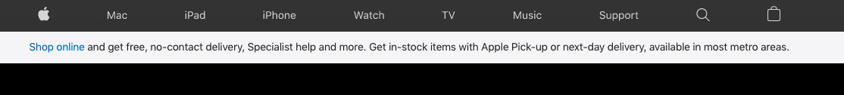

The other web site we found is Apple webpage(<https://www.apple.com/au/>). We thought that the design of the navigation bar is simple and grab the user’s eyes easily. The black colour background and the white colour of font are matching well so we want to apply this style into our webpage.

**(2) footer**



The footer style we found is from <https://www.csscodelab.com/>. The footer has basic and needed information about Home, About Us, Contact Us and copyright. Our group members’ thought is putting key information about company in footer and the feature of this webpage’s footer is good and clear to have all key information about company. Through our discussion we apply to this feature into our website.

**(3) map**

The first relevant map we found was google map <https://news.google.com/covid19/map>. When we visited the homepage, what appeared was a COVID map, each state marked the number of recent cases and show us the location of the case. On the right-hand side, it got the small button “+”, “-”, this will let user easy to make the map bigger or smaller. We thought that it is useful structure that users can zoom in and zoom out the map. This simple design makes the website easy to use.

**2. Log in**

We find the log-in page from RAA <https://www.raa.com.au/>. We decided to design a simple and easy-to-understand login interface to provide the necessary functions and information while being simple. The login page of RAA, this is very simple, divided into two sides, one is account login, the other is login with social account. The login interface we designed will be similar to this one. The feature and structure of this page grab our eyes. We would add a sentence “Are you a shop owner?” under the “Don’t have an account?”.

**3. Sign up**

For the venue sign-up page, we got some idea from this link <https://instapage.com/blog/sign-up-page>. We want to design a simple and easy-to-understand venue sign up interface to provide the necessary functions and information while being simple. When we saw this one, we think it give us some idea of the venue sign-up page, the feature and the structure. We got some idea from this sign-up page; the venue signs up interface we designed will be similar to this one but may change the background colour.

**4. Check-in history**

In the check in page, we got some idea from this link <https://www.trivago.com.au/>. After the user login to the user page, we want the user history check in show on the user page like this. This module is very suitable for showing users the timeline of their check-in. In this way, it is also very convenient for users to find the time, place and location of their check-in. This appearance also looks very clear and clean, without making users unable to quickly find their history. Through the discussion, we want to use this kind of structure, feature and style while we make the webpage for check-in history.

**5. Check in**

For check in part, instead of using QR code, we think about using “venue nearby” check-in, we would have a input place for you to input the venue id to check-in and also get your location, list the venue nearby you and check in just like the the design above from chivago [https://www.trivago.com.au/], and the bracket will show location information and also a button for you to check-in , we would also have an automatically check-in to let you check in the nearest venue by clicking one button and we discuss that it is good structure for checkin.

**6. Account manage page (user)**

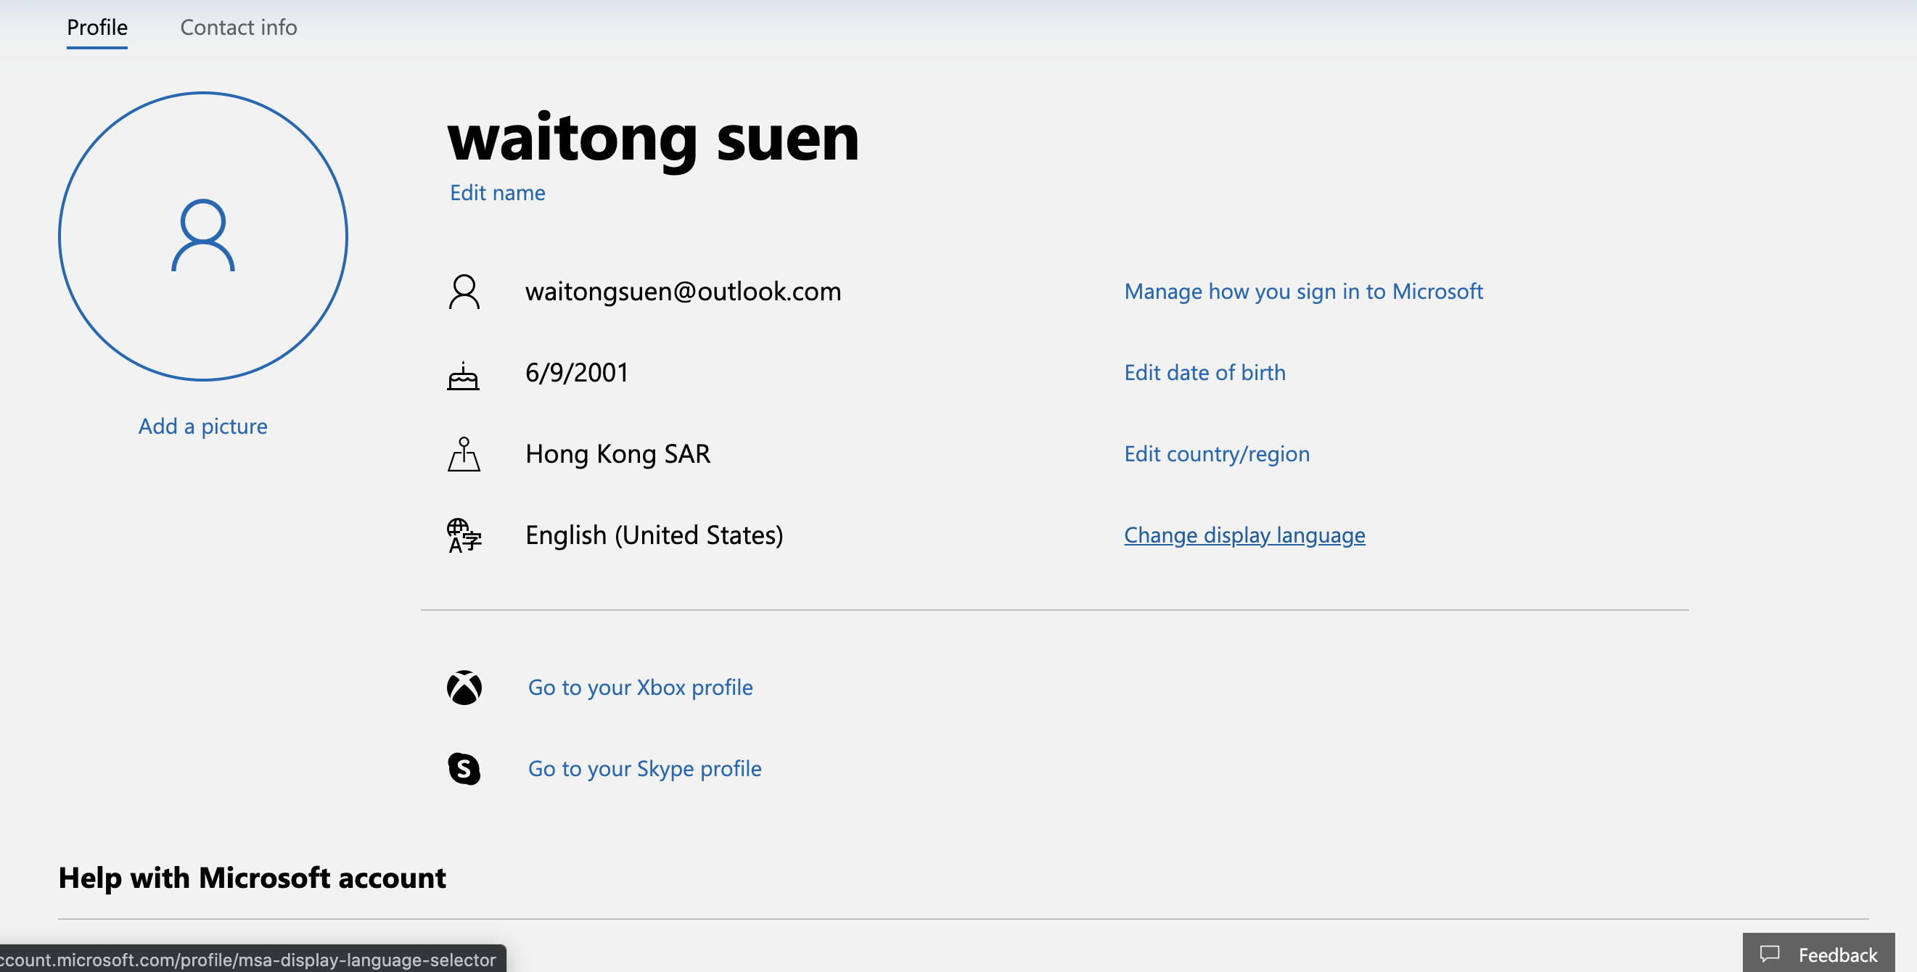

For individual user, we prefer to use the layout from outlook email account (https://outlook.live.com/). This layout is clear, low cognitive load, user don’t have to think too much while they want to change their information, the affordance of this layout is pretty high due to the graph(symbol) relevant to the information. The relevant information for user list together, the feedback button would directly link to the contact us.

**7. Contact us page**

For the contact us page, we find some idea from this website page <https://my.gov.au/mygov/content/html/contact.html>. It got information about contact number, place open time and email information. We think the structure and feature from this page is good, but it would little be simple. So we may add a picture to the side of the contact us information.

**7. About us page**

The About Us webpage is from <https://www.tate.org.uk/about-us>. The style of this page grabs our attention. This page separates the information about the company by different section of box, which is clear and attractive. The structure and feature of this page are well organised. We also want to use few images that can represent our company and make the page aesthetic. It can make the user approach our website more in friendly way.